PROJECT PROPOSAL

BLOOD DONATION FINDER
A Real-Time Web Platform for Emergency Blood Connection

Submitted by:
Aryan Mainalee
Dipesh Bastola
Sulav Tiwari

Group 7
Under the Supervision of:
Sanju Shrestha

Contents
INTRODUCTION 3
Background of the Project 3
Domain Explanation 3
Context of the Problem 3
PROBLEM STATEMENT 4
Specific Challenges Identified 4
Who is Affected 5
Impact of the Problem 5
OBJECTIVES OF STUDY 5
Primary Goal 5
Specific Objectives 5
METHODOLOGY 6
Requirement Identification 6
Study of Existing Systems 6
Identification of User Needs 6
Feasibility Study 7
Technical Feasibility 7
Operational Feasibility 7
Economic Feasibility 7
High-Level Design 8
System Flow: 8
Basic Architecture 8
Working Mechanism 9
11
GANTT CHART 14
14
Phase Summary 15
EXPECTED OUTCOME 16
Delivered System 16
Final Result 16
REFERENCES 18

INTRODUCTION

Background of the Project
Blood donation is one of the most critical components of emergency medical care. Timely access to the right blood type can mean the difference between life and death in medical emergencies, surgical procedures, trauma cases, and chronic illnesses such as thalassemia. Despite the global emphasis on healthcare improvement, the process of connecting blood donors with recipients remains largely fragmented, slow, and reliant on outdated manual methods.
In Nepal, the challenge is particularly critical. Hospitals and blood banks often face shortages, especially for rare blood groups, and the existing infrastructure for donor-recipient coordination is inadequate. Families in emergencies resort to frantic phone calls, social media appeals, and word-of-mouth to find donors, resulting in life-threatening delays.

Domain Explanation
This project operates at the intersection of healthcare informatics and web application development. It leverages real-time web technologies to create a digital bridge between voluntary blood donors and individuals or organizations in need of blood. The platform falls under the domain of health technology (HealthTech), specifically addressing emergency response systems and donor management systems.
Modern web technologies such as Node.js, Socket.io, and MySQL provide the technical foundation to build a scalable, reliable, and real-time platform that can function effectively even under high-demand emergency conditions.

Context of the Problem
The absence of a centralized, real-time blood donor connection system in Nepal means that during medical emergencies, precious time is wasted searching for compatible donors. Blood banks maintain limited supplies and often run out during high-demand periods such as natural disasters or disease outbreaks. Voluntary donors exist but are not systematically registered or easily reachable. This project directly addresses these systemic gaps by developing a structured digital platform.

PROBLEM STATEMENT
The current blood donation and emergency transfusion system in Nepal suffers from severe structural and operational deficiencies that delay life-saving medical interventions. The core problem can be defined as follows:
There is no reliable, centralized, and real-time digital platform in Nepal that effectively connects blood donors with recipients during medical emergencies, resulting in critical delays, preventable loss of life, and an inefficient use of available donor resources.

Specific Challenges Identified
- Difficulty in Finding Donors Quickly: In emergency situations, there is no fast mechanism to identify and contact nearby compatible blood donors. The process currently depends on manual phone searches and social media posts, which are slow and unreliable.
- No Proper Platform for Donor Connection: Existing systems, if any, are fragmented and do not provide a unified interface for donors, recipients, and blood bank organizations to interact in real time.
- Delays Due to Manual Processes: Phone-based and person-to-person searches introduce significant time delays. In critical care situations, even a one-hour delay can be fatal.
- Outdated Donor and Blood Records: Donor registrations, if maintained, are often outdated with incorrect contact information, blood type records, or availability status.
- Shortage of Rare Blood Groups: Rare blood types (e.g., AB-, O-) are especially difficult to source, and there is no efficient system to locate such donors across a region.
- Low Public Awareness of Blood Donation: Many eligible individuals are unaware of donation opportunities, eligibility criteria, or how to register as a donor.
- Need for Secure Data Storage: Donor and recipient health data require strict confidentiality and secure management, which existing informal systems fail to provide.

Who is Affected
The problem affects multiple stakeholders: patients requiring emergency blood transfusions, their families, hospitals and clinics operating in resource-constrained environments, blood bank organizations, and voluntary blood donors who lack a proper platform through which to offer their help.

Impact of the Problem
The cumulative impact of these challenges includes preventable fatalities, increased pressure on hospital resources, donor disengagement due to a lack of streamlined processes, and an overall weakening of the national blood supply infrastructure. A digital solution that addresses these pain points has the potential to save lives and strengthen public health capacity.

OBJECTIVES OF STUDY

Primary Goal
To develop a fast, reliable, and user-friendly web-based platform that connects blood donors with recipients in real time, reducing emergency response delays and improving blood availability across Nepal.

Specific Objectives
The following measurable objectives guide the development of this system:
- Develop a fast donor connection system that allows recipients or hospitals to post blood requests and receive donor responses within minutes.
- Create a reliable and accurate platform that maintains up-to-date records of registered donors, blood types, and availability status.
- Design a simple and intuitive user interface that can be used by individuals with minimal technical literacy, including patients' families and volunteers.
- Reduce delays in finding donors by automating the matching process based on blood type, location, and donor availability.
- Improve communication between users through integrated real-time in-app chat and email/SMS notification features.
- Maintain a structured donor database using MySQL that ensures data integrity, security, and efficient query performance.
- Ensure quick emergency response capability by enabling instant notifications and real-time updates on blood request statuses.

METHODOLOGY
The development of the Blood Donation Finder follows a structured, phase-based software development approach. The methodology encompasses requirement identification, feasibility analysis, and high-level system design, followed by iterative development, testing, and deployment.

Requirement Identification
This phase focuses on understanding the existing landscape and identifying the precise needs of users and stakeholders.

Study of Existing Systems
- An analysis of existing blood donation applications such as HamroLifeBank and BloodConnect.org was conducted to understand current features, limitations, and user expectations.
- Academic literature including studies on blood supply chains, voluntary donation practices in Nepal, and the impact of disasters on blood supply were reviewed (see References).
- The traditional system of manual phone-based donor searches was studied to identify specific pain points and inefficiencies.

Identification of User Needs
- Blood Recipients/Families: Need a fast, simple way to post emergency blood requests and find compatible nearby donors.
- Blood Donors: Need a platform to register their availability, manage donation history, and receive timely notifications.
- Organizations/Blood Banks: Need an administrative dashboard to monitor requests, manage donor records, and coordinate responses.
- System Administrators: Need tools to oversee platform operations, manage users, and ensure data integrity.

Feasibility Study
A comprehensive feasibility analysis was conducted across three dimensions to ensure the viability of this project.

Technical Feasibility
The project is technically feasible using widely adopted and well-documented web technologies. The chosen stack - HTML, CSS, and JavaScript for the front end; Node.js and Express.js for the back end; MySQL for the database; and Socket.io for real-time communication - is a standard, production-proven combination. All technologies are open-source, have large developer communities, and are supported by extensive documentation. The use of Nodemailer with Gmail SMTP for email notifications and JWT-based authentication adds proven, enterprise-grade capabilities without additional licensing costs.

Operational Feasibility
The system is operationally feasible. The user interface will be designed for simplicity and accessibility, requiring no specialized training for basic operations. Donor registration, blood request submission, and real-time matching are designed to be intuitive workflows. The platform can be maintained by a small team after deployment. Operational procedures including user onboarding, request management, and admin oversight are clearly defined within the system design.

Economic Feasibility
The project has a low development and maintenance cost profile. All core technologies are open-source and free to use. Hosting can be achieved using affordable cloud platforms. The development is being carried out by the project team as an academic exercise, minimizing labor costs. The long-term operational costs are limited to server hosting, domain registration, and email service usage, all of which are minimal compared to the social value delivered. No proprietary software licenses are required.

High-Level Design
The system architecture is designed for scalability, real-time communication, and data integrity.

System Flow:
- A user (donor or recipient) registers on the platform and creates a profile with blood type, location, and contact information.
- A recipient in need posts a blood request specifying blood type, quantity, urgency level, and location.
- The system automatically filters and notifies compatible donors in the same city or district using the donor matching logic.
- Notified donors can accept the request and initiate real-time communication through the in-app chat feature.
- The request status is tracked and updated (Open, Fulfilled, or Expired) throughout the process.
- Email and in-app notifications keep all parties informed of status changes.
- An admin dashboard allows organizations and administrators to oversee all activity and manage records.

Basic Architecture
- Frontend: HTML, CSS, JavaScript, responsible for rendering user interfaces and handling client-side interactions.
- Backend: Node.js with Express.js, handles routing, business logic, authentication (JWT), and API endpoints.
- Real-Time Layer: Socket.io, enables real-time bidirectional communication for in-app chat and instant notifications.
- Database: MySQL, stores structured data for users, donors, blood requests, chat logs, and donation history.
- Notification Service: Nodemailer with Gmail SMTP, sends automated email alerts for blood requests and updates.

Working Mechanism
The platform follows a client-server model. When a blood request is posted, the server processes the request, queries the database for compatible available donors in the relevant geographic area, and emits real-time socket events to notify matching donors. Donors receive instant browser notifications and email alerts. The two-way chat feature is powered by Socket.io, allowing direct communication once a donor accepts a request. All data is securely stored and managed in the MySQL database, with JWT tokens managing session authentication.

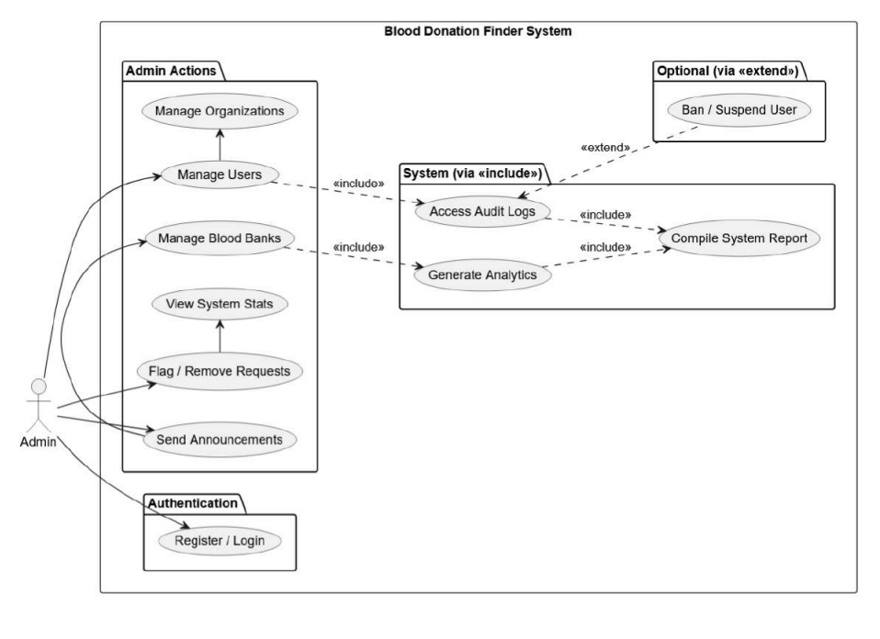

Figure 1.1: Use Case Diagram (Admin)

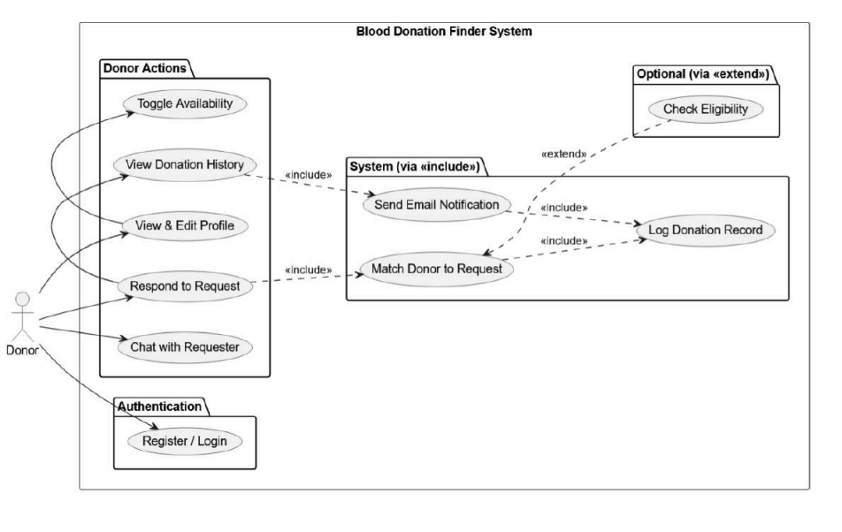

Figure 1.2: Use Case Diagram (Donor)

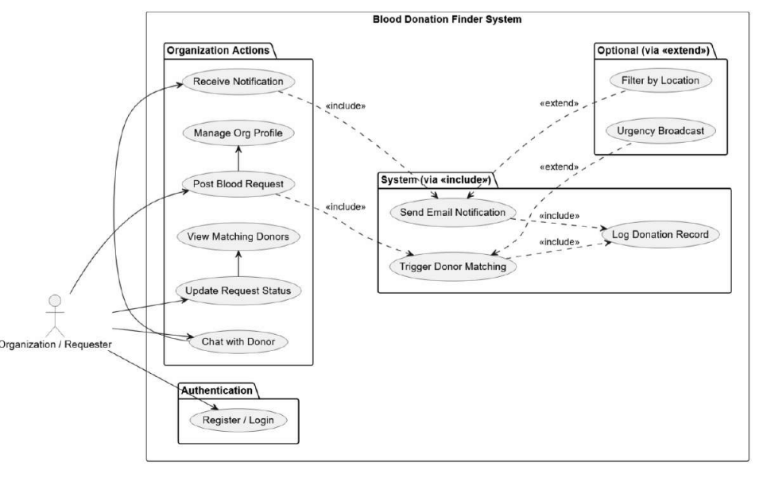

Figure 1.3: Use Case Diagram (Organization/Requester)

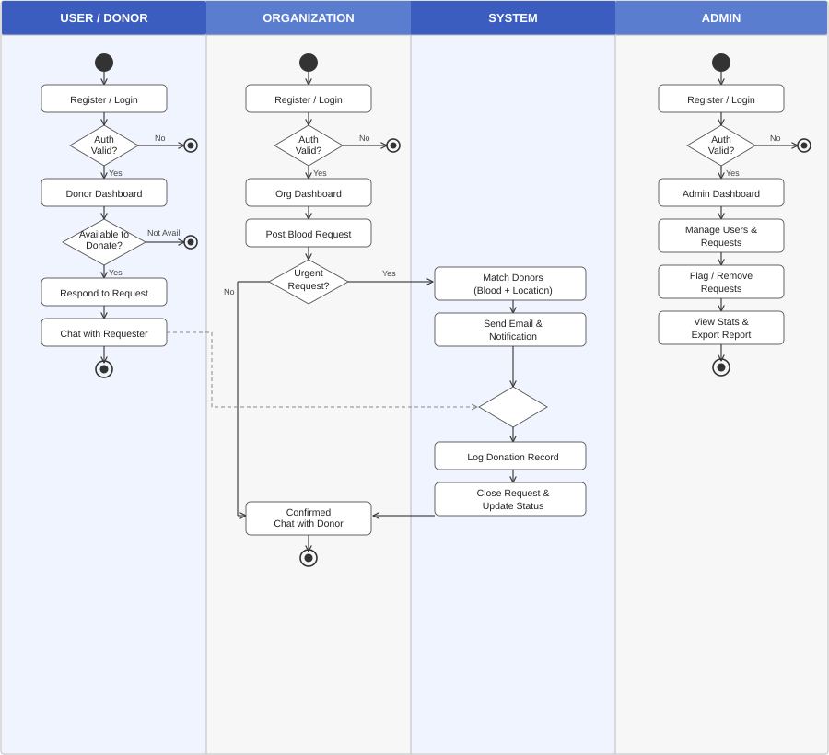

Figure 2: Flowchart of Blood Donation System

GANTT CHART
The project is planned over a 13-week timeline, divided into five structured phases. The table below illustrates the task distribution across weeks:

Figure 3: Project Gantt Chart

Phase Summary
- Initiation (Weeks 1-2): Team formation, role assignment, project scope definition, and technology stack confirmation.
- Planning & Setup (Weeks 3-4): Requirement gathering, UI wireframing, ER diagram creation, MySQL schema design, and project environment setup (Node/Express/MySQL boilerplate).
- Core Development (Weeks 5-8): Implementation of core features including JWT authentication, user/donor registration flows, blood request CRUD system, city/district-based donor matching logic, and request status tracking (Open/Fulfilled/Expired).
- Secondary Features (Weeks 8-10): Development of email notifications via Nodemailer, real-time in-app chat using Socket.io, and per-user donation history logging.
- Testing & Delivery (Weeks 10-12): End-to-end integration testing, bug fixes, UI polish, edge case handling, and final deployment with presentation preparation.
- Documentation (Continuous): Project documentation maintained throughout all phases, covering system design, API references, and user guides.

EXPECTED OUTCOME
Upon successful completion of the project, the Blood Donation Finder will deliver the following outcomes:

Delivered System
- A fully functional, deployed web application accessible via a public URL, enabling blood donors and recipients across Nepal to connect in real time.
- A secure user registration and authentication system supporting both individual donors and organizational accounts.
- A real-time blood request and donor matching engine that filters donors by blood type and geographic location and delivers instant notifications.
- An integrated in-app chat system powered by Socket.io enabling direct communication between donors and recipients.
- An automated email notification system ensuring all parties receive timely updates on blood requests and responses.
- A donor availability toggle allowing donors to manage their active status, preventing irrelevant notifications.
- A complete donation history log per user, enabling tracking of past contributions.
- An administrative dashboard providing oversight capabilities for blood bank organizations and platform administrators.

Final Result
The final result of this project is a production-ready blood donation web application that significantly reduces the time required to find a compatible blood donor during emergencies. The system replaces inefficient manual search processes with a structured, digital, and real-time solution. It is expected to improve emergency response times, increase voluntary donor participation through a user-friendly platform, and contribute meaningfully to the healthcare infrastructure by ensuring that blood, a resource that cannot be manufactured, reaches those who need it when they need it most.
The project demonstrates the practical application of modern web technologies in solving real-world public health challenges and serves as a scalable model that can be expanded to other regions or integrated with national blood bank systems in the future.

REFERENCES

- Mdpi.com. (2023). A systematic literature review of the blood supply chain through bibliometric analysis and taxonomy. Systems, 11(3), 124. https://www.mdpi.com/2079-8954/11/3/124
- NepJOL. (2023). Knowledge, attitude and practice of voluntary blood donation among higher education students in Nepal. PJRI. https://nepjol.info/index.php/pjri/article/download/87678/66464
- ScienceDirect. (2023). Impact of natural disasters and pandemics on blood supply: A systematic review. https://www.sciencedirect.com/science/article/pii/S2772632023000132
- ResearchGate. (2024). Blood transfusion services in Nepal: An overview. https://www.researchgate.net/publication/394055105_Blood_transfusion_services_in_Nepal_An_overview
- BloodConnect. Blood donor connection platform. https://bloodconnect.org/
- Sankalp India Foundation / HamroLifeBank. Blood donation app for Nepal. https://hamrolifebank.com/

